The Book of
Revelation
Lesson Number Eight
“Walk Through the Bible” Series
© 2016 by Jay S. McMullan

The last of the seven churches that Jesus gave a letter to was the Church in Laodicea.

Revelation 3:14-22 (NLT)
¹⁴ “Write this letter to the angel of the church in Laodicea. This is the message from the one who is the Amen—the faithful and true witness, the beginning of God’s new creation: ¹⁵ “I know all the things you do, that you are neither hot nor cold. I wish that you were one or the other! ¹⁶ But since you are like lukewarm water, neither hot nor cold, I will spit you out of my mouth! ¹⁷ You say, ‘I am rich. I have everything I want. I don’t need a thing!’ And you don’t realize that you are wretched and miserable and poor and blind and naked. ¹⁸ So I advise you to buy gold from me—gold that has been purified by fire. Then you will be rich. Also buy white garments from me so you will not be shamed by your nakedness, and ointment for your eyes so you will be able to see. ¹⁹ I correct and discipline everyone I love. So be diligent and turn from your indifference. ²⁰ “Look! I stand at the door and knock. If you hear my voice and open the door, I will come in, and we will share a meal together as friends. ²¹ Those who are victorious will sit with me on my throne, just as I was victorious and sat with my Father on his throne. ²² “Anyone with ears to hear must listen to the Spirit and understand what he is saying to the churches.”

Jesus refers to Himself differently in each letter to the Churches. Jesus REVEALS different aspects about Himself to us through these references.

Revelation 2:1 (NLT)
¹ “Write this letter to the angel of the church in Ephesus. This is the message from the one who holds the seven stars in his right hand, the one who walks among the seven gold lampstands:

Revelation 2:8 (NLT)
⁸ “Write this letter to the angel of the church in Smyrna. This is the message from the one who is the First and the Last, who was dead but is now alive:

Revelation 2:12 (NLT)
¹² “Write this letter to the angel of the church in Pergamum. This is the message from the one with the sharp two-edged sword:

Revelation 2:18 (NLT)
¹⁸ “Write this letter to the angel of the church in Thyatira. This is the message from the Son of God, whose eyes are like flames of fire, whose feet are like polished bronze:

Revelation 3:1 (NLT)
¹ “Write this letter to the angel of the church in Sardis. This is the message from the one who has the sevenfold Spirit of God and the seven stars: “I know all the things you do, and that you have a reputation for being alive—but you are dead.

Revelation 3:7 (NLT)
⁷ “Write this letter to the angel of the church in Philadelphia. This is the message from the one who is holy and true, the one who has the key of David. What he opens, no one can close; and what he closes, no one can open.

And finally, to the Church in Laodicea, Jesus tells John:

Revelation 3:14 (NLT)
¹⁴ “Write this letter to the angel of the church in Laodicea. This is the message from the one who is the Amen—the faithful and true witness, the beginning of God’s new creation:

Laodicea was a city located west of Colossae in an area called PHRYGIA.

Other cities in Phrygia were Antioch in Pisidia, Colossae, Hierapolis and Iconium.

East of Phrygia was the area of GALATIA. These were like counties.

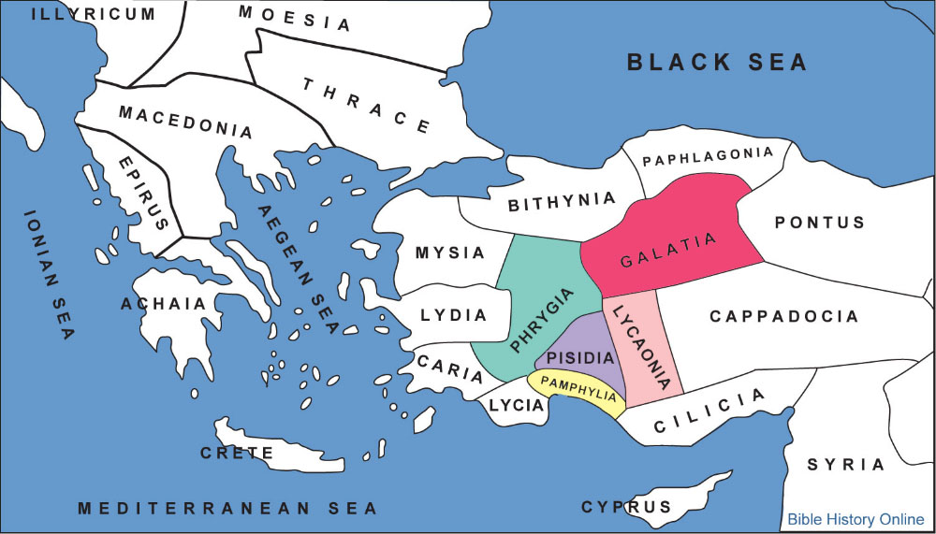
During his second missionary journey Paul, accompanied by Silas and Timothy (Acts 16:6-8), visited the "region of Galatia," where he was detained by sickness (Gal 4:13), and had thus the longer opportunity of preaching to them the gospel.
Illustrated Bible Dictionary: And Treasury of Biblical History, Biography, Geography, Doctrine, and Literature.

Acts 16:6-8 (NLT)
⁶ Next Paul and Silas traveled through the area of Phrygia and Galatia, because the Holy Spirit had prevented them from preaching the word in the province of Asia at that time. ⁷ Then coming to the borders of Mysia, they headed north for the province of Bithynia, but again the Spirit of Jesus did not allow them to go there. ⁸ So instead, they went on through Mysia to the seaport of Troas.
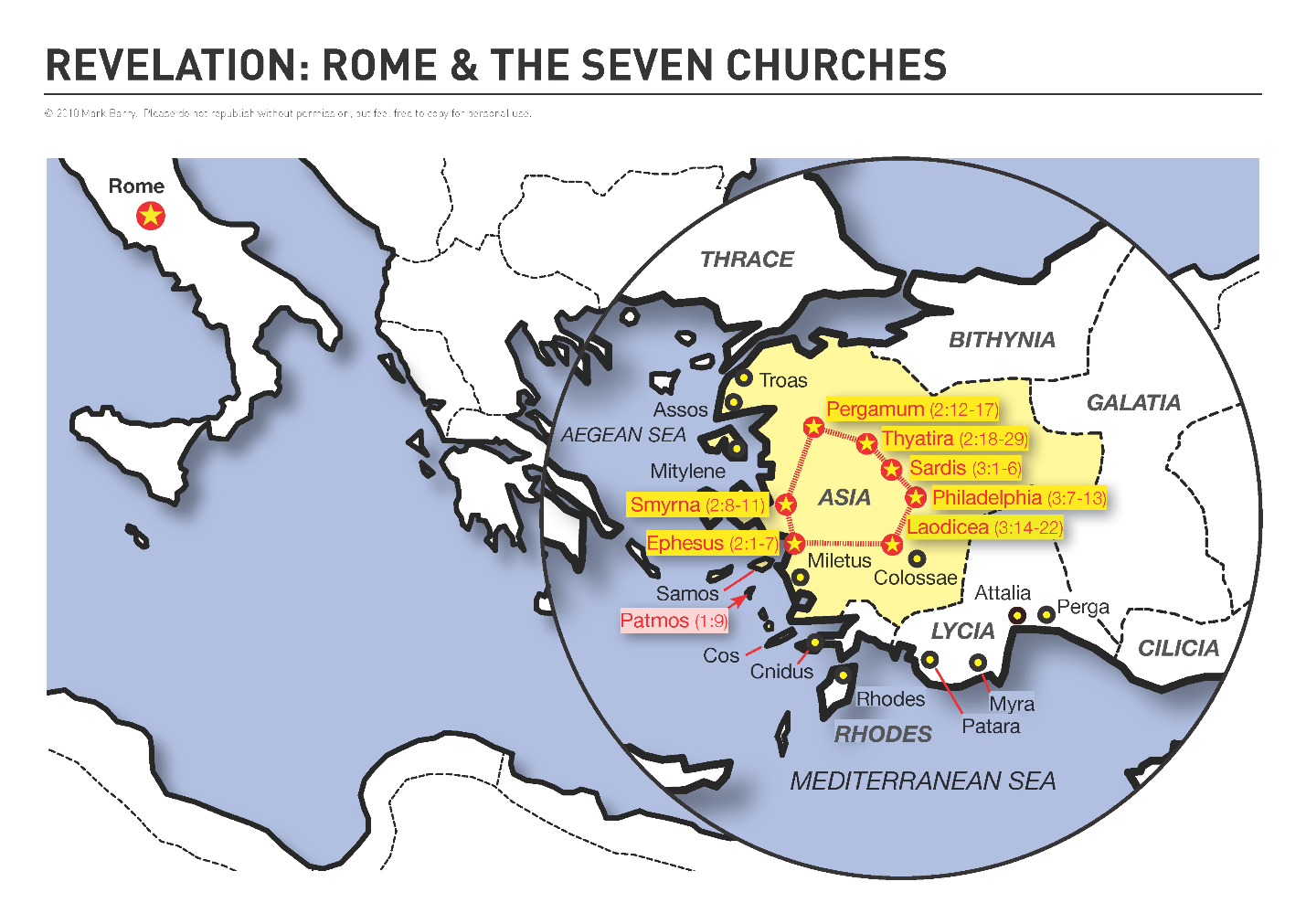

The Asia here was not all of Asia Minor, for they had already established churches in Galatia, Phrygia, Pisidia, Lycaonia, and Pamphylia (provinces of it – see map), but it no doubt was Bithynia and Mysia, the northern and western parts of Asia Minor that the Holy Spirit checked them from going into at this time (Acts 16:7). He wanted them to go to other places that were more ripe for the gospel. Later these other parts were visited when they were more ready for it (1Pet. 1:1).
Dake's Annotated Reference Bible: Containing the Old and New Testaments of the Authorized or King James Version Text.

On his third journey he went over "all the country of Galatia and Phrygia in order" (Acts 18:23). Crescens was sent there by Paul toward the close of his life (2Ti 4:10).
Illustrated Bible Dictionary: And Treasury of Biblical History, Biography, Geography, Doctrine, and Literature.

Rev. 3:14
What does it mean when Jesus says He is the one who is the Amen—the faithful and true witness, the beginning of God’s new creation.

Amen – Literally means “Yes,” “Verily” which basically means Jesus is the TRUTH!

2 Corinthians 1:20 (NLT)
²⁰ For all of God’s promises have been fulfilled in Christ with a resounding “Yes!” And through Christ, our “Amen” (which means “Yes”) ascends to God for his glory.

[beginning of the creation of God] That is, the One who began creating all things in the very beginning (Jn. 1:3; Eph. 3:9; Col. 1:15-18; Heb. 1:2; 11:3). It could not mean that He was the first to be created by God, for He is an uncreated and eternal being (Isa. 9:6-7; Mic. 5:2; Jn. 1:1-2; Heb. 1:8; Rev. 1:8, note).
Dake's Annotated Reference Bible: Containing the Old and New Testaments of the Authorized or King James Version Text.

Revelation 3:15, 16
¹⁵ “I know all the things you do, that you are neither hot nor cold. I wish that you were one or the other! ¹⁶ But since you are like lukewarm (tepid) water, neither hot nor cold, I will spit (vomit) you out of my mouth!

Notice the first thing Jesus said to the Laodiceans:
“I KNOW all the things you do!”

Jesus said this about EVERY church. Jesus knows what we do in our church.

Jesus knows what we do in our Life Group!

Jesus said that the Laodiceans said they were rich but in fact, were wretched and miserable and poor and blind and naked.

The people in the Church in Laodicea where exactly the opposite of what they said they were!

Five things about the Church in Laodicea:

- Jesus KNEW their works
- They were neither hot or cold
- Lukewarm and nauseating to the Lord
- Proud and Self-satisfied
- They were not aware of their true state

Jesus gives advice to the Church in Laodicea. In other words, He is giving advice to each person in the Church! The Church IS the people!

¹⁸ So I advise you to buy gold from me—gold that has been purified by fire. Then you will be rich. Also buy white garments from me so you will not be shamed by your nakedness, and ointment for your eyes so you will be able to see. ¹⁹ I correct and discipline everyone I love. So be diligent and turn from your indifference. ²⁰ “Look! I stand at the door and knock. If you hear my voice and open the door, I will come in, and we will share a meal together as friends.

5 Things God advises the Laodiceans to do:

- Buy refined gold from Him so they could TRULY be rich
- Buy white garments from Him so they would not be ASHAMED.
- Buy ointment from Him for their eyes so they could SEE.
- Be diligent (KJV says “zealous”. Means to be “hot” or “jealous.”

Jesus corrects and disciplines everyone He loves.

He desires to have CLOSE fellowship with us.

Jesus doesn’t want to be like your very distant cousin who you only see once every twenty years.

He wants you to come in and “sup” with Him, fellowship with Him!

How many times a day do we eat? Do we eat once every twenty years like we see that distant cousin? No, we eat several times every day!

1 Thessalonians 5:16-22 (NLT)
¹⁶ Always be joyful. ¹⁷ Never stop praying. ¹⁸ Be thankful in all circumstances, for this is God’s will for you who belong to Christ Jesus. ¹⁹ Do not stifle the Holy Spirit. ²⁰ Do not scoff at prophecies, ²¹ but test everything that is said. Hold on to what is good. ²² Stay away from every kind of evil.

Jesus wants us to be OVERCOMERS!

NOTICE that Jesus said to each Church:

“Anyone with ears to hear must listen to the Spirit and understand what he is saying to the churches.

- To the Church in Ephesus

Revelation 2:7 (NLT)
⁷ “Anyone with ears to hear must listen to the Spirit and understand what he is saying to the churches. To everyone who is victorious I will give fruit from the tree of life in the paradise of God.

- To the Church in Smyrna

Revelation 2:11 (NLT)
¹¹ “Anyone with ears to hear must listen to the Spirit and understand what he is saying to the churches. Whoever is victorious will not be harmed by the second death.

- To the Church in Pergamum

Revelation 2:17 (NLT)
¹⁷ “Anyone with ears to hear must listen to the Spirit and understand what he is saying to the churches. To everyone who is victorious I will give some of the manna that has been hidden away in heaven. And I will give to each one a white stone, and on the stone will be engraved a new name that no one understands except the one who receives it.

- To the Church in Thyatira

Revelation 2:26-28 (NLT)
²⁶ To all who are victorious, who obey me to the very end, To them I will give authority over all the nations. ²⁷ They will rule the nations with an iron rod and smash them like clay pots. ²⁸ They will have the same authority I received from my Father, and I will also give them the morning star!

- To the Church in Sardis

Revelation 3:5 (NLT)
⁵ All who are victorious will be clothed in white. I will never erase their names from the Book of Life, but I will announce before my Father and his angels that they are mine.

- To the Church in Philadelphia

Revelation 3:12 (NLT)
¹² All who are victorious will become pillars in the Temple of my God, and they will never have to leave it. And I will write on them the name of my God, and they will be citizens in the city of my God—the new Jerusalem that comes down from heaven from my God. And I will also write on them my new name.

- To the Church in Laodicea

Revelation 3:21 (NLT)
²¹ Those who are victorious will sit with me on my throne, just as I was victorious and sat with my Father on his throne.

How can we be Overcomers and be Victorious in this life?

John 16:33b (NLT)
,,, on earth you will have many trials and sorrows. But take heart, because I have overcome the world.”

John 15:20 (KJV)
²⁰ Remember the word that I said unto you, The servant is not greater than his lord. If they have persecuted me, they will also persecute you; if they have kept my saying, they will keep yours also.

We are to be like Jesus and we will be when we serve Him. He suffered persecution but yet He OVERCAME! We will too if we follow what the Word of God tells us.

Revelation 12:11 (KJV)
¹¹ And they overcame him by the blood of the Lamb, and by the word of their testimony; and they loved not their lives unto the death.

Homework:

This week, take the time to write out your testimony.
† How did you hear about Jesus and His sacrifice for you?
† How did you feel when the Holy Spirit convicted you of your sins?
† How has your life changed since you were saved?

Next, answer these questions.
† Have you suffered persecution for being a Christian?
† Is there any specific thing you have learned that has made your Christian experience easier?

